**SET A**

You've been assigned the development of a Library Management System. The library system is composed of multiple branches, each housing an array of books and multimedia resources. The library catalog includes various types of items, such as Books, DVDs, and Journals. Each library item is identified by a distinct code, contains information about its acquisition date, and is associated with a specific author or creator.

Library patrons can engage in activities such as borrowing items, returning them, and checking the availability of resources. In addition to the general library items, special features are implemented for different types of items. For instance, books can be reserved, DVDs have a return date, and Journals provide access to specific articles.

Library patrons are allowed to have multiple borrowed items, but each item is uniquely associated with one patron. The library is managed by a team of employees, each having a unique ID, name, hiring date, and expertise level indicating their experience in the library system.

The library staff is divided into two categories: Librarians and Assistants. Both roles have distinct attributes and methods tailored to their specific responsibilities within the library system. It is essential to ensure that the attributes and methods are appropriately configured for Librarians and Assistants to efficiently manage the library resources and provide quality service to patrons.

Create a class diagram based on the given scenario.  **[10]**

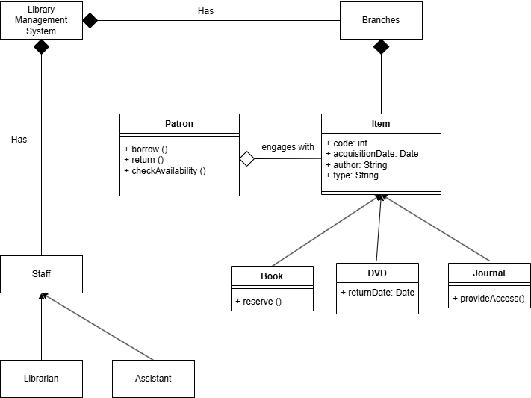

**SET B**

You have been tasked with creating a Bank Management System. A Bank has many Branches which offer various types of bank accounts, these accounts consist of Savings Account, Deposit Account, and Loan Account. Each bank account has a unique identifier, an opening date, interest rate and an owner(customer).Accounts can be used to deposit money, withdraw money and check balance. Loan Accounts have add_loan and payback_loan and Deposit Account has a withdraw_time .A customer can have multiple bank accounts, but a bank account can only belong to one customer. A bank is run by employees, every employee has a unique ID,name, joining date and an experience value(No of years worked in current company).

Employees are of two types: Manager and Staff. They have their own attributes and methods, fill them up appropriately.

Create a class diagram based on the given scenario.  **[10]**

